Lehigh Valley United
Off Season Fitness Guide
The Importance of Off-Season Nutrition & Fitness

- To start the pre-season with good fitness and strength levels, saving time that would be wasted playing catch up during the hard early weeks of preseason

- To eliminate the potential for injury during pre-season

- To make sure that you come back lean and with maximum fuel and muscle supplies

- To make sure you come back fresh and hungry as you have given yourself enough rest and recovery from the stresses and strains of competitive soccer

- To work on weaknesses or strengths, these may be technical or physical things you believe you need to improve on. The time off allows you to practice these things, so you can come back even better than before.

Starting the Season with a Greater Baseline Fitness level

Detraining - Detraining is the loss off aerobic fitness, strength, and power due to periods of inactivity. This means that you will have to restart training from a decreased level of fitness.

Detraining is a major cause of pre-season injury! This occurs due to differences between strength and flexibility.

When training is stopped or reduced for a long period of time, a loss of all of the fitness components to the right will follow.

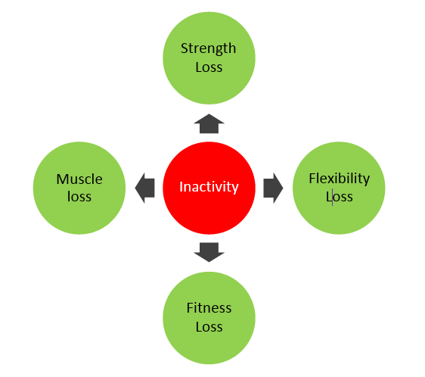

“Players who suffer a hamstring injury at some point during the season typically have a reduced range of flexibility at the start of pre-season training”

Nutrition Guidelines – Eating the Right Amount in the Off-Season

When you stop exercising for a short time your body will not need as much energy. It is important to drop your food intake when you don't exercise, otherwise your body will store the unneeded energy as fat.

If your energy intake from food is roughly the same as the energy you use in exercise your body weight will stay the same

If your energy intake from food is greater than the energy you use in exercise you will put on body weight

It is important therefore to slightly drop your food intake during the off season on days when you have not trained.

To reach this target, you should be aiming to have:

- 10 - 15 grams of fat per meal
- 70 - 90 grams of carbohydrate per meal
- 20 - 25 grams of protein per meal

Smaller players should be eating the lower amount of grams per meal, and larger players should be eating the higher amount

Off-Season Fitness Program

For the pre-season period to be most effective, during the off season players should continue to work on:

- Muscular Strength
- Aerobic Fitness
- Core Stability
- Flexibility
- Body Weight
- Speed
- Agility

PLEASE NOTE for the following exercises you should know your own limits, and DO NOT push yourself too hard at the risk of losing good technique and DO NOT attempt to carry out any exercises that you are not comfortable with.

U18 Off-Season Fitness Program 2014

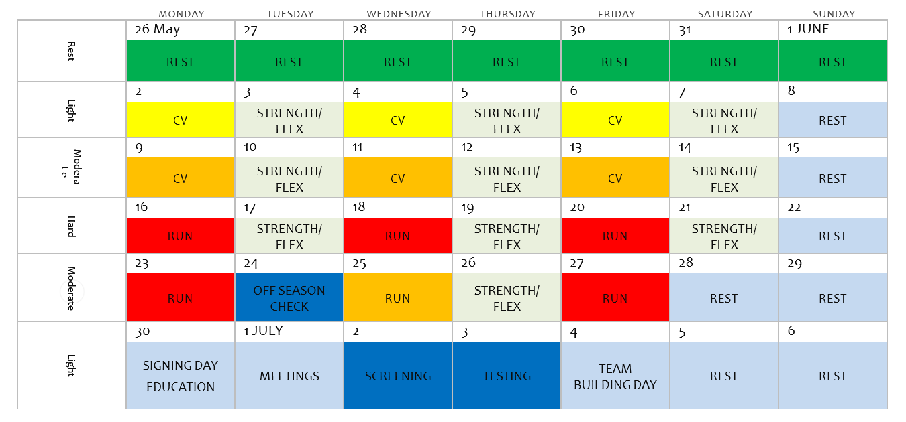

Exercise Chart

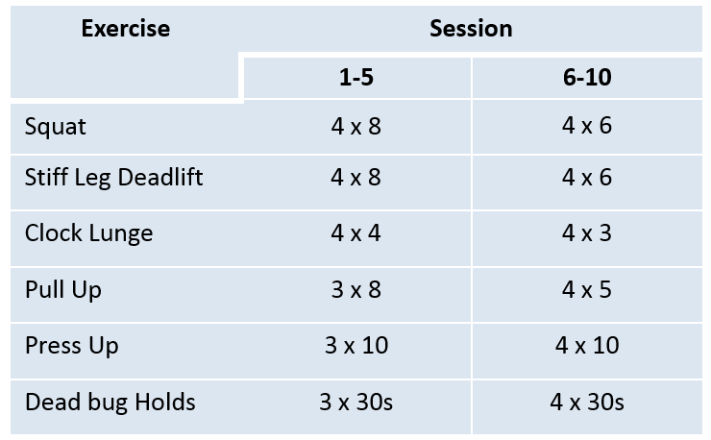

Strength: Perform all exercises with ‘perfect’ technique
Flexibility: Dynamics & static stretches for all major muscle groups
Mixture of stretches for calfs, quads, glutes, hamstrings, etc

Each player will also be aware of exercises and activities that they should be doing for their own personal preparation for preseason. You should ensure that you make time to complete the individual components of your program to help your resilience to injury next season

Use your common sense, look after yourself and come back in good condition to begin preseason training

Lunges

Static: Stand with right foot forward, left foot back about 3 feet apart.
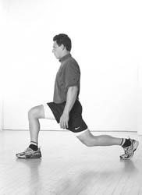
Bend the knees to lower the body towards the floor. Keep the front knee behind the toes and be sure to lower straight down rather than forward.
Keep the torso straight and abs in as you push through the front heel and back to starting position.
Don't lock the knees at the top of the movement.

3 sets of 8 with 1 minute rest between sets

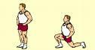
Dynamic: Lunge forward with first leg. Land on heel then forefoot. Lower body by flexing knee and hip of front leg until knee of rear leg is almost in contact with floor. Return to original standing position by forcibly extending the hip and knee of the forward leg. Repeat by alternating lunge with opposite leg.

3 sets of 8 with 1 minute rest between sets

Walking (Continous):

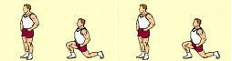
Step forward with first leg. Land on heel then forefoot. Lower body by flexing knee and hip of front leg until knee of rear leg is almost in contact with floor. Stand on forward leg with assistance of rear leg. Lunge forward with opposite leg. Repeat by alternating lunge with opposite legs.

3 sets of 8 with 1 minute rest between sets

Push-Ups

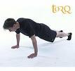
Normal Push-Up:
Hold your trunk tight and keep your back straight in a normal press- up position with hands shoulder width apart / directly under your shoulders. Lower yourself so your chest almost touches the floor and push up until your arms almost fully extend.

2 sets of 10 with 1 minute rest between sets

Narrow/Wide Push-Up:
Same as above but alter starting position into wider grip (about 1-metre between hands) or a narrow grip (hands along-side each other).

2 sets of 10 with 1 minute rest between sets

One Leg Push-Up:
Same as above but alter position so that one leg is raised from the ground throughout the press up.

2 sets of 10 with 1 minute rest between sets

Elevated Leg Push-Up:
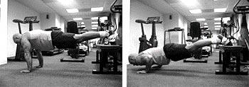
Same as above but alter starting position so that legs are raised onto object (e.g bench or medicine ball).

2 sets of 10 with 1 minute rest between sets

Dips

Sitting Dips:
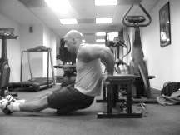
Place your hands on the bench with palms down and your knuckles facing forward. Hands should be slightly closer than shoulder width apart. As you are doing this you will bend at the knees and your legs should be at a 90-degree angle. Lower your body by bending at the elbow. Exhale slowly as you bend. Lower for a count of two. Elbows should not point out away from the body as you lower. Straighten your arms out. This will push your body back up. Inhale slowly through your nose as you straighten your arm.

2 sets of 8 with 1 minute rest between sets

Bench-to-Bench Dips:

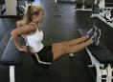
Same as above except feet start resting on bench opposite.

2 sets of 8 with 1 minute rest between sets

Standing Dips:
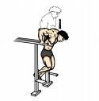
Position yourself on the parallel bars and support yourself at arms’ length (arms should be straight). Keep your feet suspended in the air with knees bent, keep your back and torso straight (your feet should be behind). Lower your body until you feel a feel the stretch (lowering and raising your body should be done with the elbows bent); your shoulders should be 90- degrees angle apart and supporting your entire body weight. Slowly push yourself back up to the starting point.

2 sets of 8 with 1 minute rest between sets

Chin-Ups

Normal Chin-Ups:
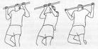
Grasp the bar palms and fingers forward, away from the body. Keep arms straight and hang straight down without swinging. Relax your shoulders and body. Pull up in a smooth motion, do not jerk. The chin should go over the bar. Lower smoothly back to the starting position.

3 sets of 2 – 4 with 1 minute rest between sets

Wide Chin-Ups:
Same as above except grip the bar wider than shoulder width.

3 sets of 2 – 4 with 1 minute rest between sets

Narrow Chin-Ups:
Same as above except grip bar narrow with hands close together.

3 sets of 2 – 4 with 1 minute rest between sets

Pull-Ups:
Same as above except grip bar with palms facing you.

3 sets of 2 – 4 with 1 minute rest between sets

Lateral (Lying) Chin-Ups:

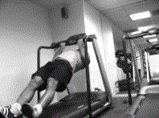
Same as above except executed from lying position, with bar in line with chest

3 sets of 2 – 4 with 1 minute rest between sets

High Intensity Running – Field Drills

- The aim of these high intensity running sessions is to attain a heart rate of 90%-95% of your max and maintain this intensity for as much of the session as possible.

- The sessions are demanding, both physically and mentally, however it will improve your ability to perform and recover from bouts of high intensity activity during games.

- Wear a Heart Rate Monitor for the session. The speeds are only a guideline – the durations may need to be increased or decreased 1-2 seconds for desired intensity.

- Field based drills are a little more game specific, displaying similar conditions to a match/training

- Work for 4 minutes and complete 3-4 sets, depending on the stage in the off-season.

- It is important to warm up before starting any of these exercises. Focus on warm-ups to prepare your body for high intensity running.

High Intensity Running – Field Drill #1

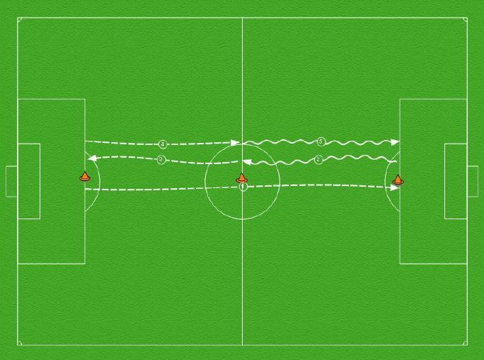

- Sprint from one penalty spot to the other (15 Seconds)
- Jog to the halfway line as recovery (15 Seconds)
- Sprint to the original penalty spot, then turn around and sprint back to the hallway line (15 seconds)
- Jog to the opposite penalty spot as recovery (15 Seconds)

Repeat 4 sets of 4 minutes, with 2-3 minutes active recovery between

High Intensity Running – Field Drill #2

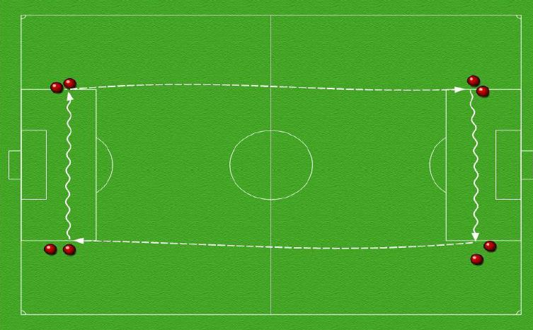

- Sprint from one side of the box level with the penalty spot to the same position on the opposite side (15 Seconds)
- Jog across the penalty area as recovery (15 Seconds)
- Sprint back to the other side of the penalty box you started at (15 Seconds)
- Jog across penalty area to starting location (15 Seconds)

Repeat 4 sets of 4 minutes, with 2-3 minutes active recovery between

High Intensity Running – Field Drill #3

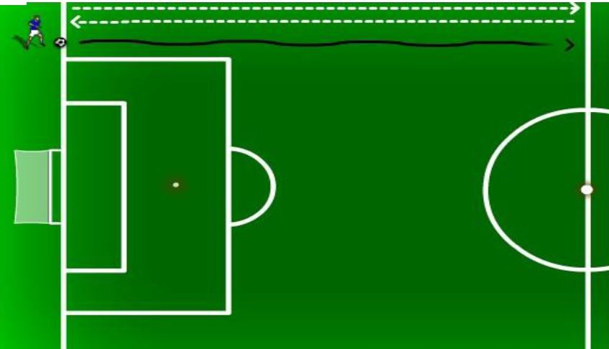

- Run with the ball from the goal line to the halfway line, then leave the ball at the halfway line.
- Run without the ball back to the goal line, and return back to the halfway line.
- Run with the ball back to the goal line, then leave the ball at the goal line.
- Run without the ball to the halfway line, and return to the goal line.
- Repeat and cover as much ground as possible in 4 minutes.

Repeat 4 sets of 4 minutes, with 2-3 minutes active recovery between

Speed – Session 1

The basis of the speed drills is a 10 yard sprint. You should focus on accelerating as quickly as possible by powering away with your arms and legs.

Set up 2 Balls 10 Yards apart, and run the following drills at each cone:

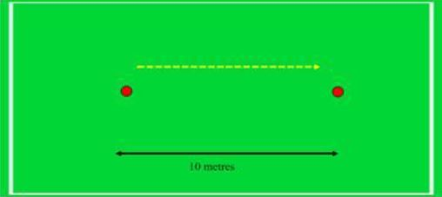
- Do 3 push-ups and sprint
- Do 5 ball touches and sprint
- Have someone toss a ball to your feet to settle and lay off, then sprint
- Run backwards for 5 yards, then turn and Sprint

3 sets of 4-6 reps, with 1 minute of recovery between

Speed – Session 2

- Set up a series of markers similar to the diagram below.
- Starting at the first marker, sprint to the second marker and sidestep to the next marker.
- Repeat until at the last marker
- Rest and repeat in the opposite direction so that you are sidestepping in the other direction.
- Work both sides

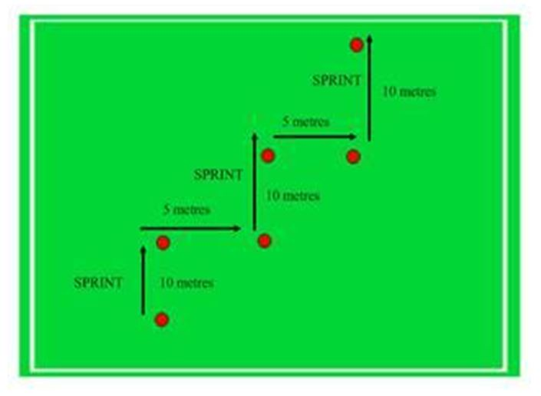

3 sets of 4-6 reps, with 1 minute of recovery between

Speed – Session 3

- Use the dimensions of the penalty area (or similar set up with cones)
- Take a starting position on the penalty spot
- Sprint to one corner of the box and walk back
- Sprint to the next corner and walk back and repeat for all 4 corners

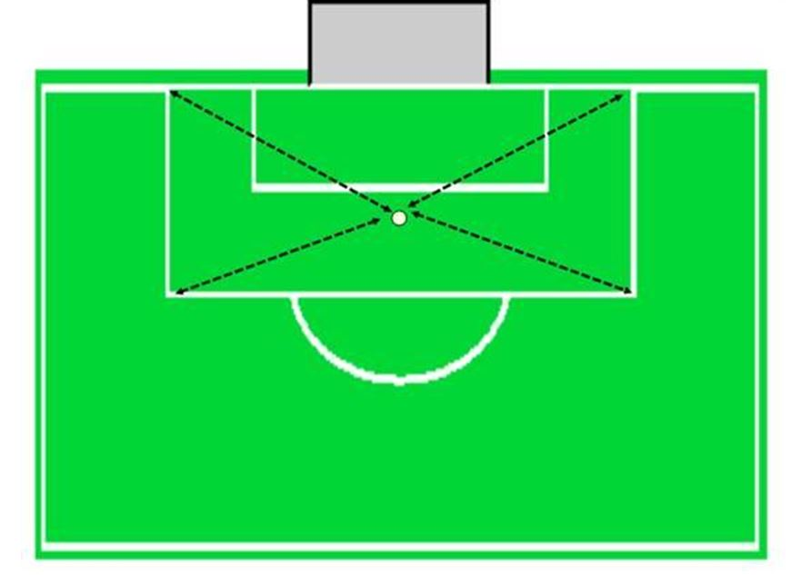

3 sets of 4-6 reps, with 1 minute of recovery between

Agility – Session 1

- Sprint around the slalom course
- Markers should be around 3 meters apart

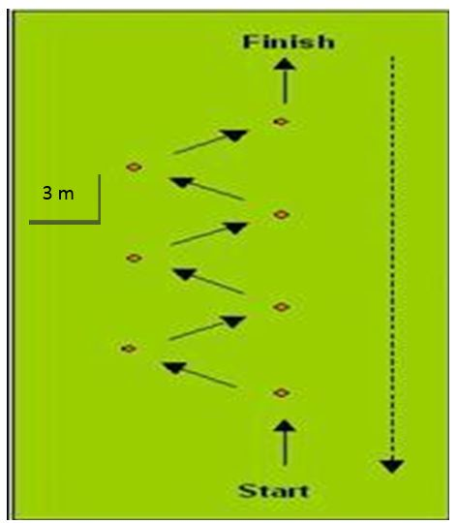

3 sets of 4-6 reps, with 1 minute of recovery between

Agility – Session 2

- From the start position, sprint to one end
- Turn and sprint to the opposite end
- Turn once more and sprint back to the middle

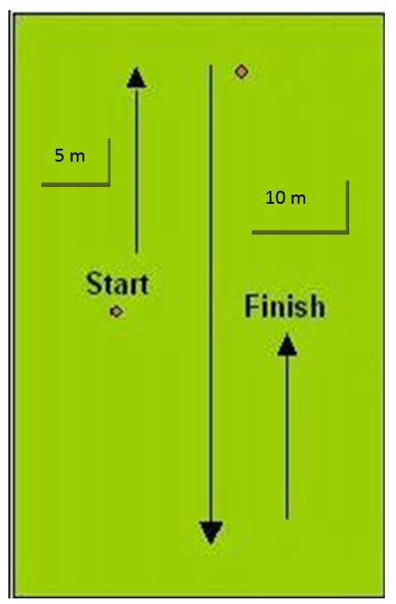

3 sets of 4-6 reps, with 1 minute of recovery between

Stretching

Stretching has a number of major benefits for sports performance, including:

- Enhances force production
- Enhances ability to learn and perform skilled movements
- Increases mental and physical relaxation
- Enhances body awareness
- Reduces the risk of injury to joints, muscles, and tendons
- Increases flexibility
- Reduces muscular soreness
- Reduces muscular tension
- Improves Coordination
- Improves blood supply

Flexibility Stretches
Calf Stretch:

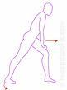
Place leg with the calf to be stretched extended behind the torso, the opposite leg is placed forward with the knee bent. Lean gently forward until stretch can be felt.

Hold for 20 second and repeat with opposite leg

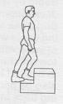
Step on a small platform or on a step, with one heel hanging in the air. Press down towards the ground until you feel a stretch. Both knees should be slightly bent.

Hold for 20 second and repeat with opposite leg

Quad Stretch:
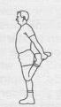
Stand and touch wall or stationary object for balance. Grasp top ankle or forefoot behind. Pull ankle or forefoot to rear end. Straighten hip by moving knee backward.

Hold for 20 second and repeat with opposite leg

Hip Flexor:
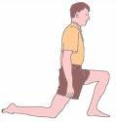
Lunge forward onto back knee. Position front foot beyond knee. Straighten hip of rear leg by pushing hips forward, without leaning forward.

Hold stretch for 30 seconds. Repeat with opposite leg.

Hamstring Stretch:

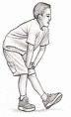
Place leg with the calf to be stretched extended behind the torso, the opposite leg is placed forward with the knee bent. Lean gently forward until stretch can be felt.

Hold for 20 seconds and repeat with opposite leg.

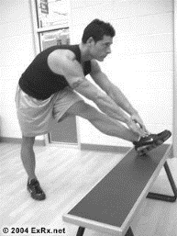
Place foot on bench or elevation. Reach toward foot on bench or bring torso toward leg.

Hold for 20 seconds and repeat with opposite leg.

Groin Stretch:

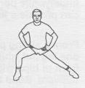
Stand with your legs wide apart. Shift your weight to one side. Do not let your knee bend beyond your ankle. You should feel the stretch in your opposite leg, which remains extended. Both of your feet stay flat on the ground facing forward.

Hold for 20 seconds and repeat on the opposite side

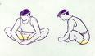
Sitting on the floor with the soles of the feet together, sit up straight with feet grasped. The stretch is felt in both sides of the groin and down the inside of both thighs.

Hold for 20 seconds

Core Stretches

Core stability is the development of the key core muscles around the trunk to provide effective distribution of force and pelvic control during movement.

Plank:
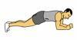
Lie face down resting on the forearms, palms flat on the floor. Push off the floor, raising up onto toes and resting on the elbows. Keep your back flat, in a straight line from head to heels. Tilt your pelvis and contract your abdominals to prevent your rear end from sticking up in the air.

Hold for 30 seconds

Side Plank:

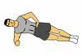
Lift your body of the ground and balance on one forearm and the side of your foot. Contract your abdominals and relax your shoulders.

Hold for 30 seconds

Bridge:
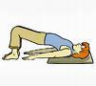
Lie flat on your back on a mat with your knees bent pointing up to the ceiling and your arms at your sides. Simply raise your pelvis up toward the ceiling to a point where your body will be at a about a 45 degree angle relative to the floor.

Hold for 30 seconds. Progress to raising one leg off the floor.

Track your progress!

